Preferences Menu

Personal Settings
Color Options
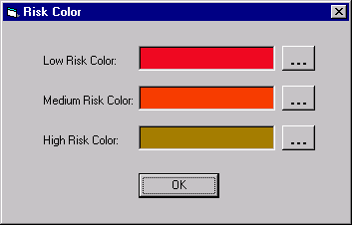
Risk Color

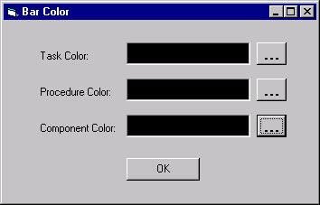
Bar Color

Workspace Color
Color Scheme
Calendar Risk Level Representation

Mode Display (background/ bar)

Project Settings

Mode Color (should also include risk cut off values)
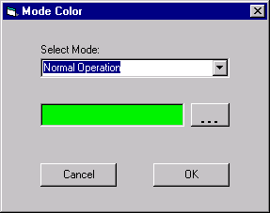
Hierarchy

Workspace Settings (start and end date)

